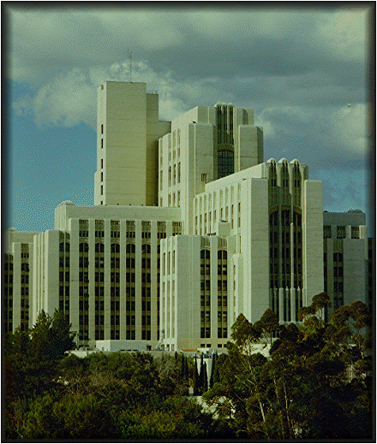
Please Pray for Josiah

Completed in 1932, LAC-USC is an impenetrable
concrete fortress capable of housing 1,500 patients
and 46,000 staff. Unfortunately, the hearts within

often show themselves to be even more impenetrable.

2 Corinthians 1:3-4,10,11
Praise be to the God and Father of our Lord Jesus Christ, the Father of compassion and the God of all comfort, who comforts us in all our troubles, so that we can comfort those in any trouble with the comfort we ourselves have received from God…On Him we have set our hope…As you help us by your prayers. Then many will give thanks on our behalf for the gracious favor granted us in answer to the prayers of many.

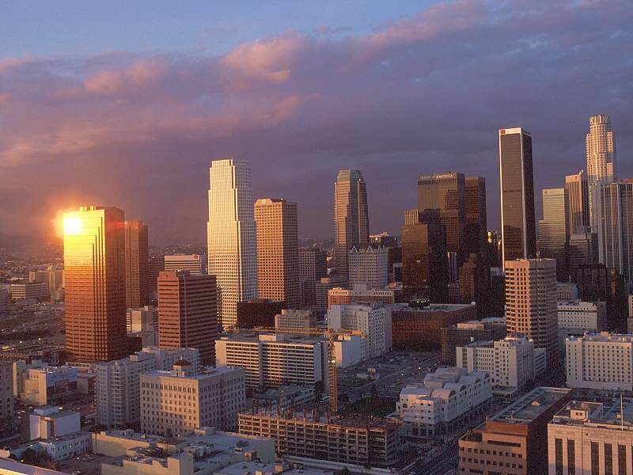
Merry Christmas

The people that walketh in darkness,
Hath seen a great light,
They that dwelleth in the land of the shadow of death,
A light hath dawned. Isa. 9:2

But to those who fear my name,
the Sun of Righteousness will arise
with healing in His wings… Mal. 4:2

*Downtown Los Angeles

If you are receiving this letter it means that
God has used you to bless me in some way;
for this I thank you. If there is any way that
I can pray for you, please let me know. Lastly, if you would like to continue receiving this letter, or you know someone else who would, please write down those addresses below, thank you, God bless.
Josiah & Crystal Grauman
405 E. Fairview Ave., Apt. #6
Glendale, Ca 91207
______________________________________________________________________________________________________________________________________________________
__________________________________________________

