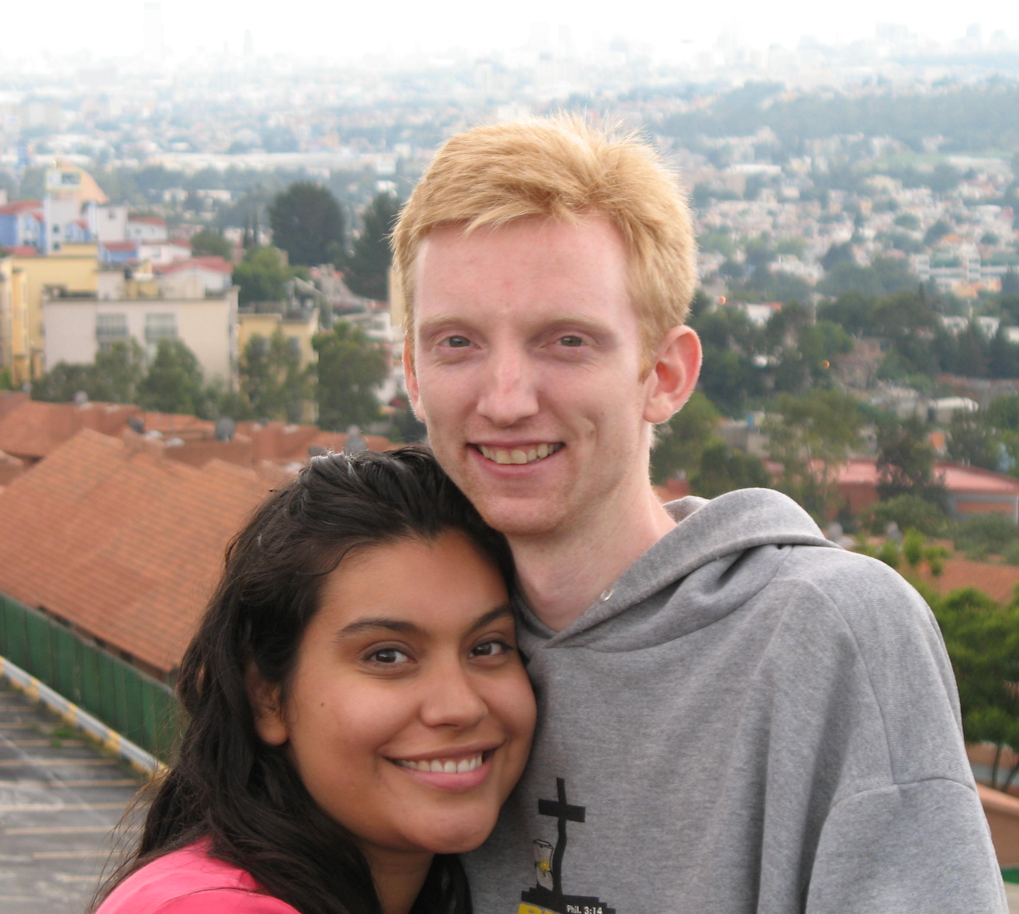
Josiah and Crystal, January 2007

A Jewish Rabbi in 1096 AD wrote in his Aramaic poem “Could we with ink the ocean fill, and were the skies of parchment made, were every stalk on earth a quill, And every man a scribe by trade, to write the love of God above would drain the ocean dry. Nor could the scroll contain the whole, though stretched from sky to sky” (Translated by F. M. Lehman in “The Love of God”).

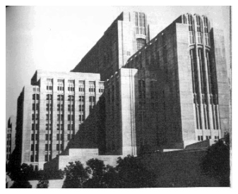
If this Rabbi, who was still looking to a God he did not know for a Messiah he thought had not yet come…if he could have been touched so tenderly by the sweetness of God’s sovereignty recorded for him in Scripture, how much more should we who have Christ? As we have been reflecting upon the faithful goodness of God this New Year, we are left without words. With the hymn-writers of old, we long for a thousand tongues to sing a celestial sonnet from above. None of our words do justice; none of our languages suffice to speak the ineffable praises of His worth.

FIFTH YEAR AS CHAPLAIN AT LAC-USC
What a blessing it has been! I cannot begin to explain what a sanctifying experience it has been upon my soul to work so closely with death these past years. Man is a vapor destined for Hell, but Christ, He is the hope of eternal life. It is an inexpressible joy to have the opportunity every day to share this hope with those who have none. For this reason, it is a very bitter-sweet thought that we will be leaving soon.
LA County Hospital
MOVING TO MEXICO AS MISSIONARIES
Why Mexico? On average, over 2,000 patients, mostly Hispanic, come into LA County Hospital / Outpatient Clinic every day. Given that this is only one Hospital of thousands, someone who has a burden for reaching hurting people can get over-burdened easily. I just can’t see them all! I want to, but I can’t. Of course, God is sovereign, and He will do what is best. But what should our response be to this overwhelming need?
A few of months ago, we attended a mission’s meeting where a similar question was posed. A missionary from Africa was asked, “What are you doing to address the humanitarian needs in Africa?” This was like asking him, “What are you doing to stop world hunger?” Frankly, I did not think he would answer…but he did. He quickly and simply responded, “We have a mercy ministry in our church, and we are training pastors to go plant churches with sustainable mercy ministries in them too.” It was so simple, so biblical. It is the great commission in action.
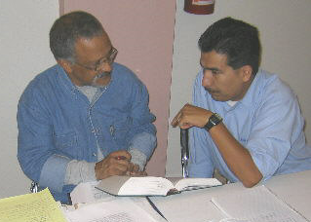
TEACHING AT WORD OF GRACE SEMINARY
I may not be able to reach everyone, but as I try, if I would pour my soul into other men, together we would reach more. This is our burden. We believe it is time, not only to serve the sick, but also to make disciples who will do the same. Therefore, when we were asked by the Seminary in Mexico, “Palabra de Gracia” (Word of Grace), to come and teach, we were ecstatic. With over one-hundred students, all desiring to learn how to shepherd the Spanish
speaking multitudes to Christ, Word of Grace Seminary seems to be a perfect home for us.


Crystal and I do need to raise support before leaving for Mexico. Of course, it is your prayers that we covet most, but if the Lord places it on your heart to give, we would be very grateful. Currently we are looking for those who would commit to giving throughout our two year stay. For example, if we estimate that we will need $3,000 a month to live in Mexico, GMI requires us to find enough supporters to commit to that amount before we leave. There are two ways made available for you to do this. First, GMI has a website http://www.gracechurch.org/ma from which you can sign in to support us. Also, any checks can be sent to GMI (address listed below). Finally, if you do give, please let us know. We would love to thank the Lord for you.

GMI c/o Grace Community Church email: josiah@grauman.com
13248 Roscoe Boulevard cell: (323) 371-3262
Sun Valley, CA 91352 web: http://www.grauman.com/josiah

-To ensure your tax deduction, please make check out to GMI and place our names in the memo line.

What exactly will we be
doing in Mexico?

Under the leadership of our good friends Luis and Robin Contreras, who are also GMI missionaries, the Seminary has flourished. There are now over 100 students! With only a few faculty members, there is a great need for more teachers.
One of the specific things that we have been asked to do is to establish the Biblical Languages program. Because there are so few resources in Greek or Hebrew available for the Spanish speaker, there is a lot to be done. In the two years that we are in Mexico, we hope to write a syllabus/textbook that can be used for years to come, not only in Mexico, but around the world.
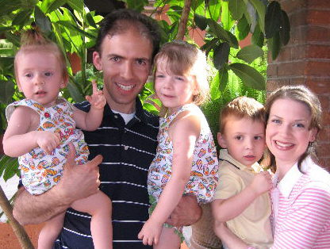

Luis and Robin Contreras

In addition, we are planning on taking an assistant pastorate at a Church near the Seminary. This will allow Crystal to be heavily involved in ministry as well.
For a more detailed explanation of why we feel the Lord is leading us to Mexico and answers to many questions, like, “What about Josiah’s health?” check out our website: www.grauman.com/josiah

Also, pray for us! Pray the Lord would direct our way, preparing not only the hearts of those we will be serving, but our own hearts as well.

