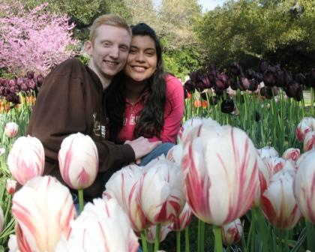
JOSIAH & CRYSTAL, MAY 2007

It was harder than I expected to delete, "and baby" from our names above. Crystal was 13 weeks pregnant when God decided to take our first child. We found out April 2nd and passed the baby here at home the next day. After 48 hours in the ER and a number of blood transfusions, we are at home resting. The Lord gave and the Lord has taken away, may we never cease to bless His name.

Descanso Gardens (We were engaged on a hill overlooking the gardens).
We have found it very sad how many people,
even Christians, speak of babies before they're born
like 'things.' What joy we have in knowing that God is the giver of life. He gave life
to our baby and has a perfect purpose for their existence. We look forward to someday praising God even more when we understand all the why.

MEXICO, HERE WE COME!

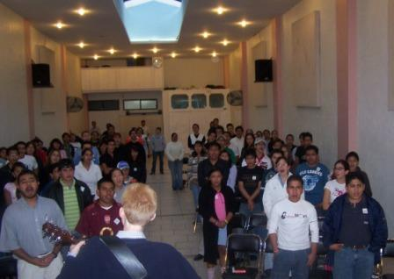
Our one way plane tickets are purchased! Our current
plan of departure, keeping in mind that "man plans his way, but the Lord determines his every step," is that I
will leave one week ahead of Crystal. This should give
my body a bit more time to acclimate to the joys (smog
and altitude) of Mexico City, along with hopefully finding an apartment and getting a bed before Crystal arrives. Crystal's flight leaves the morning of Monday, June 25th.
Singing in Mexico City

LEAVING IS BITTERSWEET

We are so excited to serve the Lord in Mexico, yet at the same time we are sad to
say goodbye to so many good friends. I will miss the Hospital as well. Last week at the Hospital Church Service, the nurses told a patient he could not come down to service.
He still had the metal halo attached from brain surgery and the drainage had not ceased. He came anyhow. Though I did not recognize him, it turns out he insisted upon coming because he was saved at a service two years ago when I was preaching and wanted to thank me! I am so thankful to the Lord for His grace, our labor is not in vain.

HOW CAN YOU PRAY?

Please continue to pray for us as we make decisions, that God would be greatly glorified. Though there are many moving details to tend to, sermons need to be prepared and class lectures need to be written! In addition, please pray with us as we are currently finilizing our budget and discussing our role at the Church where we will be serving.
We have already been so blessed by your prayers and support. We continually thank the Lord for you, may He bless you as you seek to do His will.

We also started posting weekly updates at: www.grauman.com/josiah, they are in the prayer letter section.


Financially, the Lord is providing abundantly, yet we still need to raise a significant amount before we go.
There are three ways to do this. First, GMI has a website http://www.gracechurch.org/ma from which you can sign in to support us with a credit card. Second, checks can be sent to GMI (address listed below). Or, third, you can request a form for direct withdrawal from your checking account. Finally, if you give, please let us know. We would love to thank God for you.

GMI c/o Grace Community Church email: josiah@grauman.com
13248 Roscoe Boulevard cell: (323) 371-3262
Sun Valley, CA 91352 web: http://www.grauman.com/josiah

-To ensure your tax deduction, please make checks out to GMI and place our names in the memo line.

THANKS FOR YOUR PRAYERS!

God is so good. We just heard back from Blue Cross and they are allowing us to be out of the country indefinitely without dropping our coverage! This is a tremendous blessing. We have also been praying about how to get all my medications in Mexico. As everyone knows, Costco sells everything cheap in bulk…since I take medication in bulk, it's a perfect fit! At the Costco in Mexico we can get the same medication I take here for cheaper than we pay through our insurance. It is such an encouragement to see how God is directing our way to Mexico City.

SEMINARY FINISHED!

Lord willing I will graduate from The Master's Seminary on May 13. On May 17, I preach before the elders at Grace for ordination. Then, June 10th there will be a send-off service for us in the evening. Time is flying by!!!
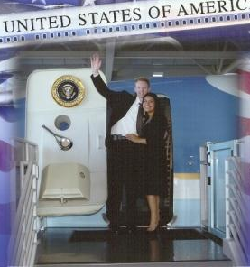
Seminary banquet tour of Air Force One

