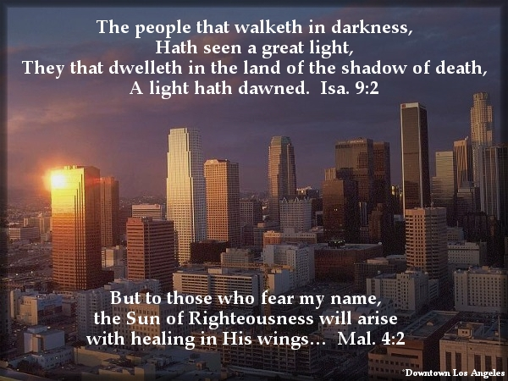

If you are receiving this letter it means that God has
used you to bless us in some way; for this we thank you.
If there is any way that we can pray for you, please let
us know. Lastly, if you would like to continue receiving
this letter, or you know someone else who would, please write down those addresses below. If you prefer to receive our letters in an email, just send us an email at josiah@grauman.com and we’ll begin
sending you an e-copy. Thank you, God bless.

Josiah & Crystal Grauman
405 E. Fairview Ave., Apt. #6
Glendale, Ca 91207
______________________________________________________________________________________________________________________________________________________________________________________________________

If you are receiving this letter it means that God has
used you to bless us in some way; for this we thank you.
If there is any way that we can pray for you, please let
us know. Lastly, if you would like to continue receiving
this letter, or you know someone else who would, please write down those addresses below. If you prefer to receive our letters in an email, just send us an email at josiah@grauman.com and we’ll begin
sending you an e-copy. Thank you, God bless.

Josiah & Crystal Grauman
405 E. Fairview Ave., Apt. #6
Glendale, Ca 91207
_____________________________________________________________________________________________________________________________________________________________________________________________

